Docker 10

For pod-a

kubectl apply -f D:\UNi\Docker & Kub\Docker 10th\kubectl apply -f pod-a.yaml\pod-a.yaml

for pod-b

How to implement Hype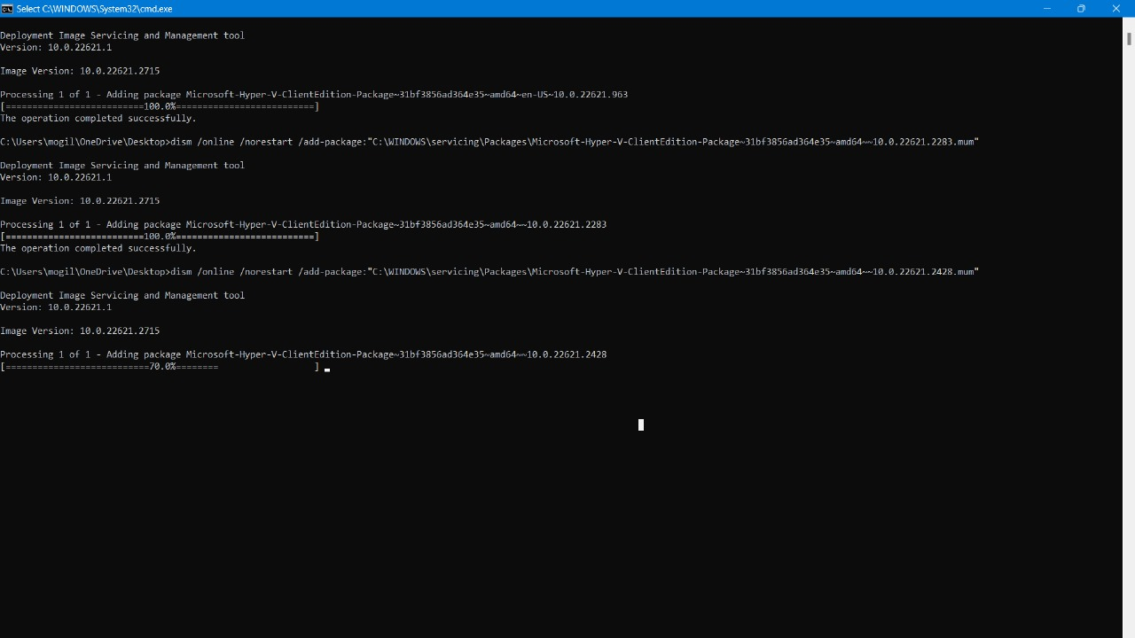rV.bat in the Window 11 system

Write the node file then open it and open again by Run As Administrator:

It will start running the image package in your system.

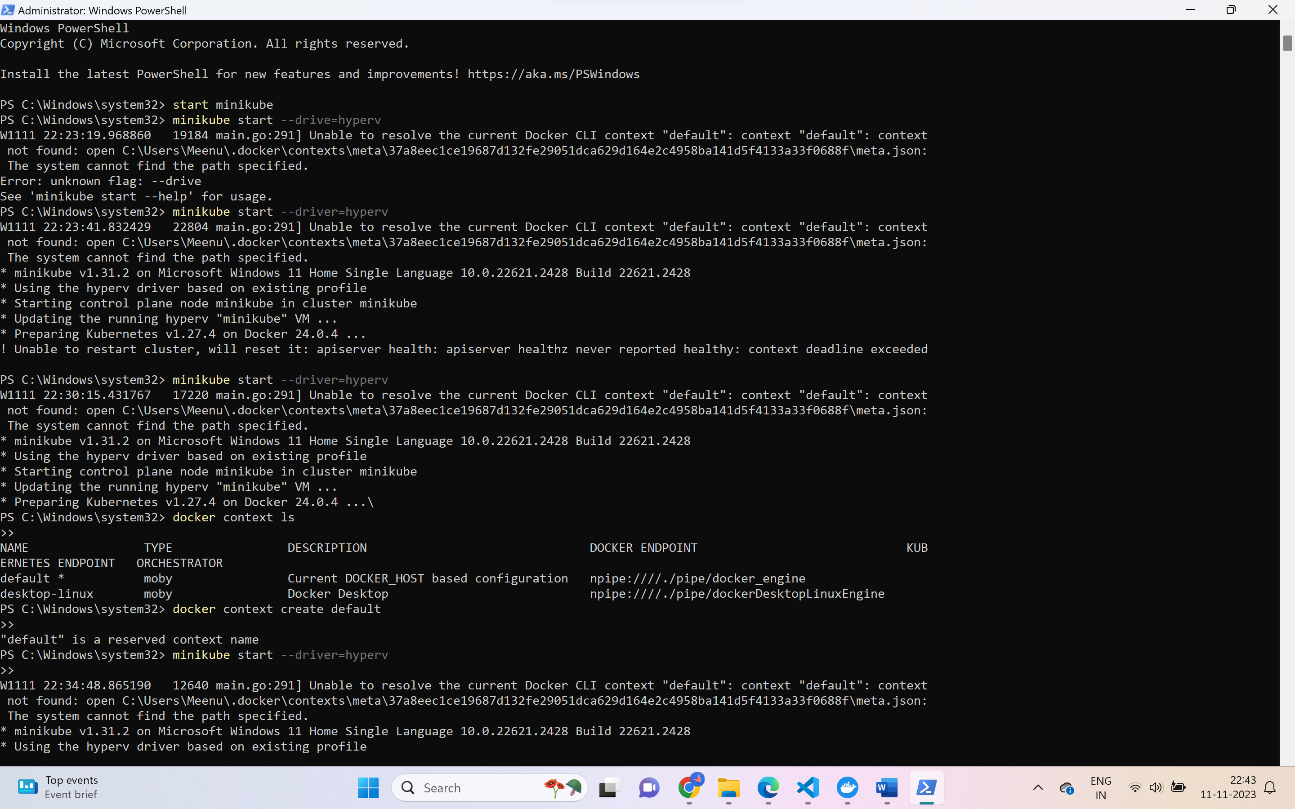

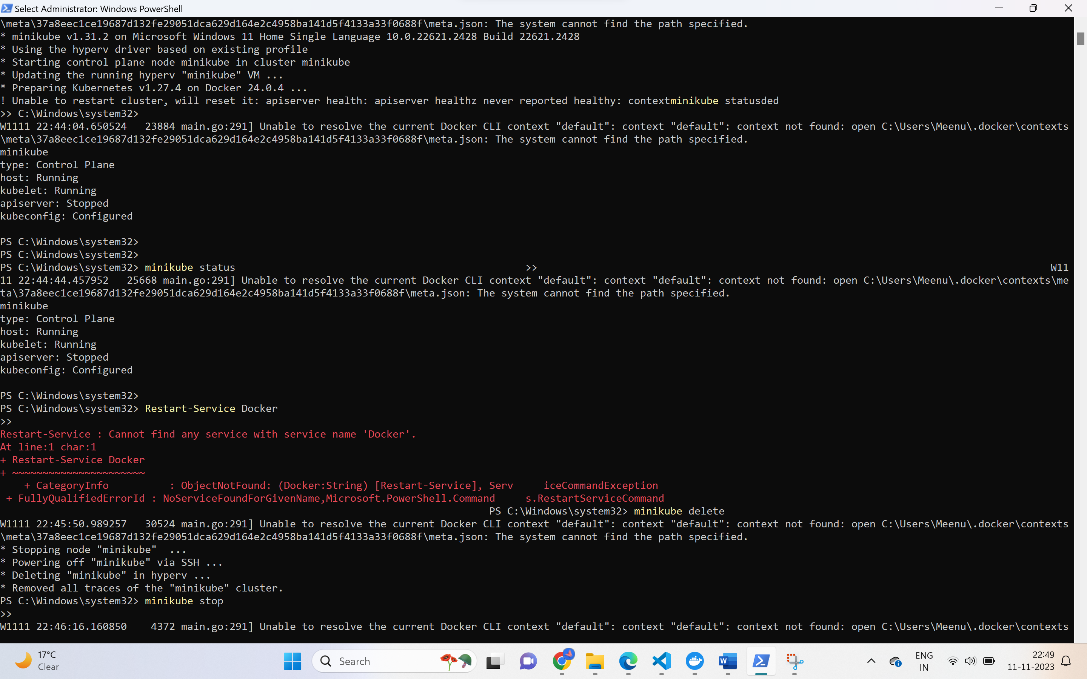

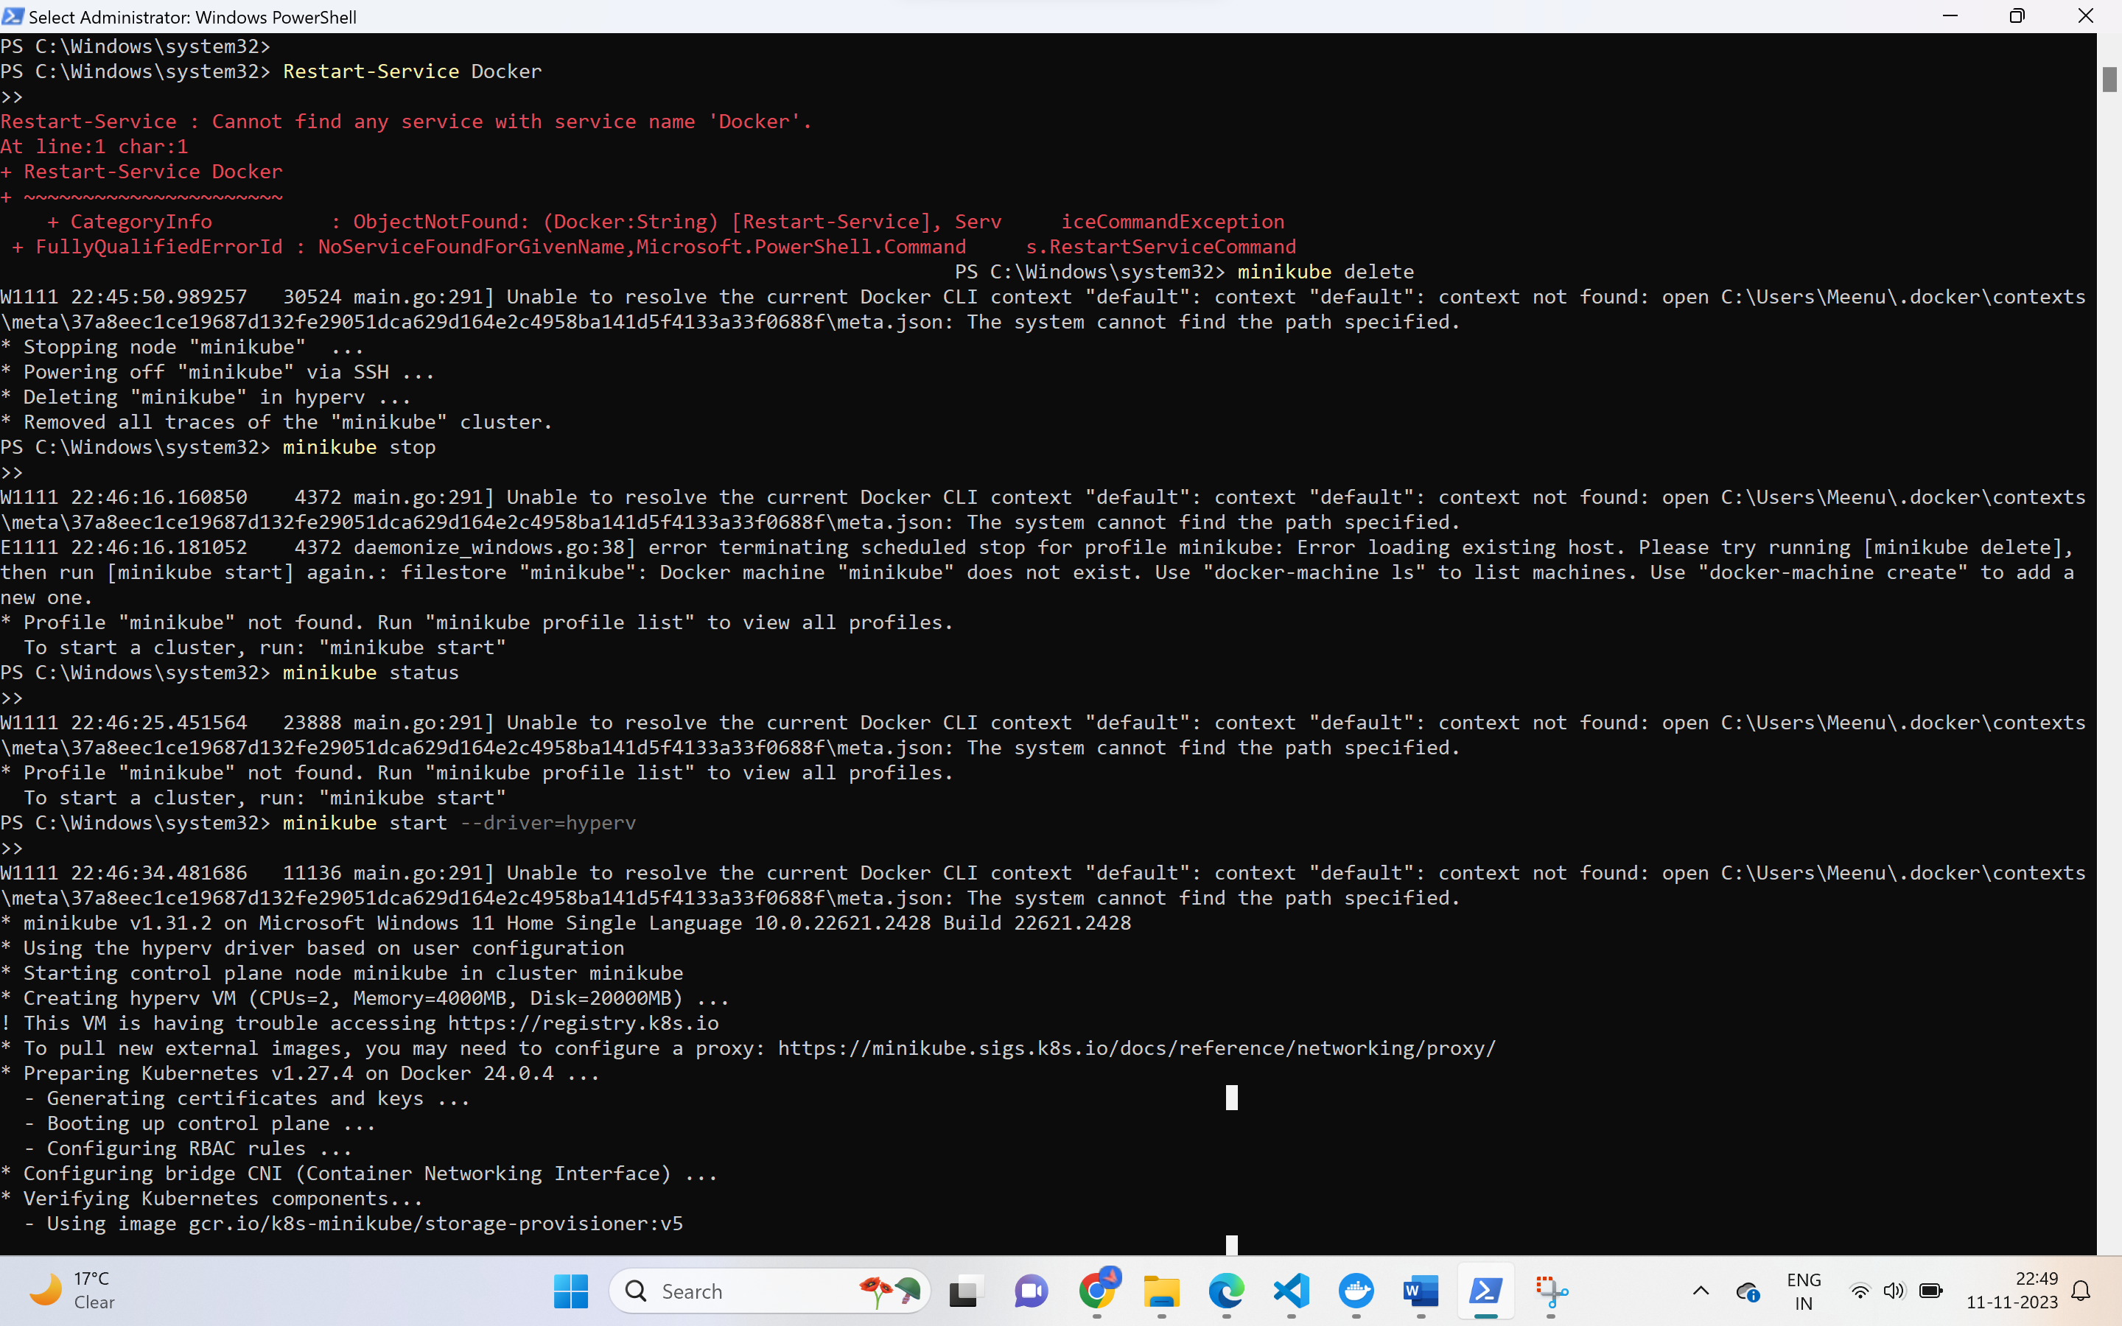



Service-b.yaml

apiVersion: v1

kind: Pod

metadata:

name: pod-b

labels:

app: pod-b

spec:

containers:

- name: container-b

image: nginx

ports:

- containerPort: 80

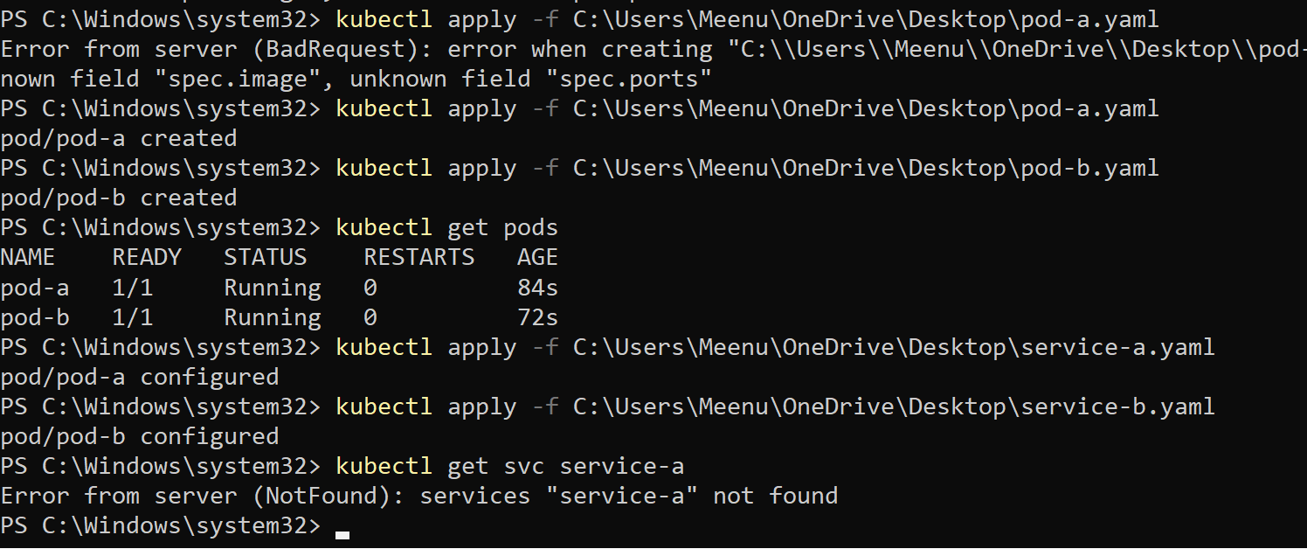

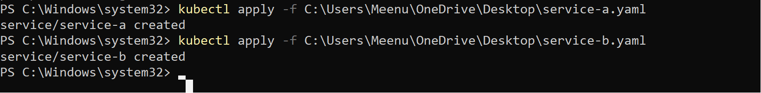

VS code program should be correct then the service-a and service-b.yaml will work

root@debug:/# curl 10.103.193.195:80

<!DOCTYPE html>

<html>

<head>

<title>Welcome to nginx!</title>

<style>

html { color-scheme: light dark; }

body { width: 35em; margin: 0 auto;

font-family: Tahoma, Verdana, Arial, sans-serif; }

</style>

</head>

<body>

<h1>Welcome to nginx!</h1>

<p>If you see this page, the nginx web server is successfully installed and

working. Further configuration is required.</p>

<p>For online documentation and support please refer to

<a href="http://nginx.org/">nginx.org</a>.<br/>

Commercial support is available at

<a href="http://nginx.com/">nginx.com</a>.</p>

<p><em>Thank you for using nginx.</em></p>

</body>

</html>

root@debug:/# curl 10.99.108.79:80

<!DOCTYPE html>

<html>

<head>

<title>Welcome to nginx!</title>

<style>

html { color-scheme: light dark; }

body { width: 35em; margin: 0 auto;

font-family: Tahoma, Verdana, Arial, sans-serif; }

</style>

</head>

<body>

<h1>Welcome to nginx!</h1>

<p>If you see this page, the nginx web server is successfully installed and

working. Further configuration is required.</p>

<p>For online documentation and support please refer to

<a href="http://nginx.org/">nginx.org</a>.<br/>

Commercial support is available at

<a href="http://nginx.com/">nginx.com</a>.</p>

<p><em>Thank you for using nginx.</em></p>

</body>

</html>

//

